King Cross-Country Spirit Wear
Purchase at the student store $13/moisture wicking Tee $26/Hoodie

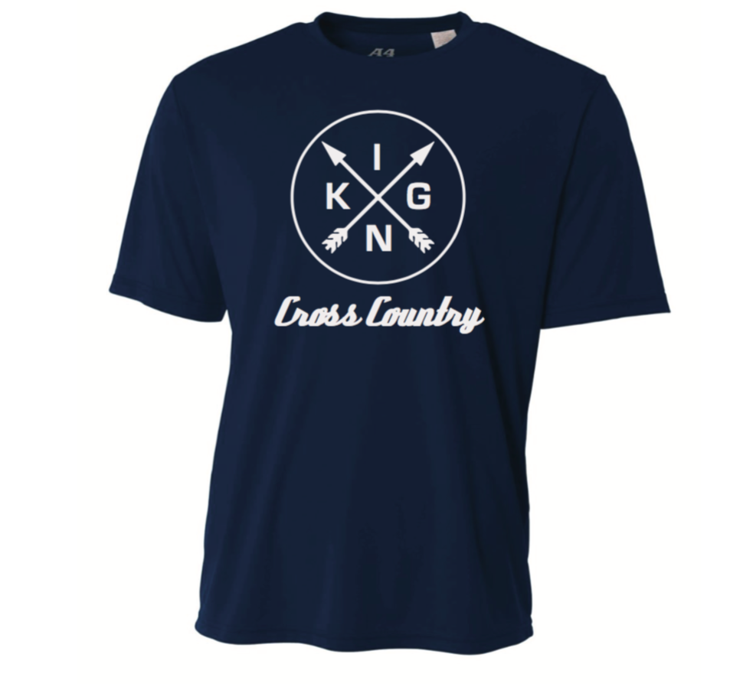

FRONT BACK

_______________________________________________________________________________________________
TURN YOUR ORDER AND MONEY IN AT THE STUDENT STORE

Athlete Name _______________________________________________________________

Tee $13 _________________________ quantity __________________Size _____________ Total _____________________

Hoodie $26 ______________________ quantity _________________ Size______________ Total _____________________

Sized YL/Adult S/M/L/XL/XXL TOTAL ___________________

Method of Payment
Cash ______________
Check ____________ check # ________________

